# Whatthischapterisabout?

asyncawait>>promisechains>>callbackhell

# SyncinJS

Synchronous

Synchronousmeansthecoderunsinaparticularsequenceofinstructionsgivenintheprogram. Eachinstructionwaitsforthepreviousinstructiontocompleteitsexecution.

Asynchronous

Duetosynchronousprogramming,sometimesimpinstructionsget blockedduetosomepreviousinstructions,whichcausesadelayintheUI. Asynchronouscodeexecutionallowstoexecutenextinstructions immediatelyanddoesn'tblocktheflow.

# Callbacks

Acallbackisafunctionpassedasanargumenttoanotherfunction.

# CallbackHell

CallbackHell:Nestedcallbacksstackedbelowoneanotherformingapyramidstructure. (PyramidofDoom)

Thisstyleofprogrammingbecomesdifficulttounderstand&manage.

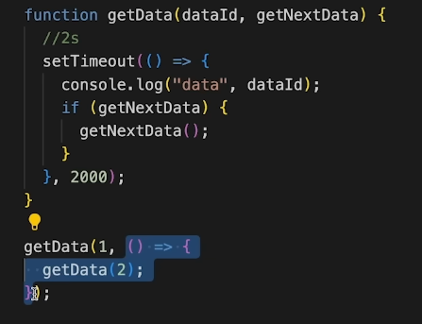 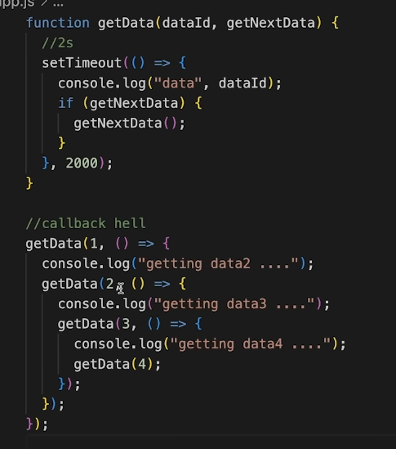

Promiseisfor“eventual”completionoftask.ItisanobjectinJS. Itisasolutiontocallbackhell.

## letpromise=newPromise((resolve,reject)=>{....})

Functionwith2handlers

*resolve&rejectarecallbacksprovidedbyJS

AJavaScriptPromiseobjectcanbe:

 Pending:theresultisundefined

 Resolved:theresultisavalue(fulfilled)  Rejected:theresultisanerrorobject

## resolve(result) reject(error)

*Promisehasstate(pending,fulfilled)&some result(resultforresolve&errorforreject).

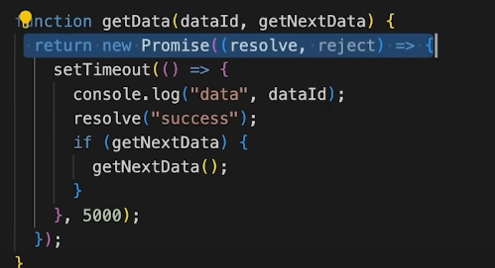

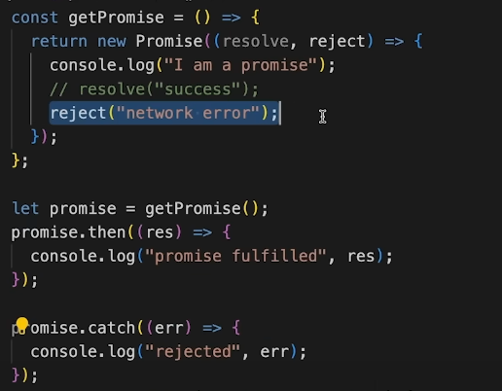

.then()&.catch()

**promise.then((res)=>{....})**

**promise.catch((err))=>{....})**

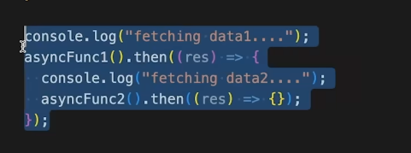

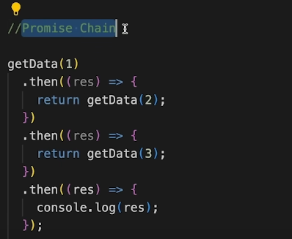

# Async-Await

asyncfunctionalwaysreturnsapromise.

## asyncfunctionmyFunc(){ }

awaitpausestheexecutionofitssurroundingasyncfunctionuntilthepromiseissettled.

AWAIT KEYWORD CAN ONLY BE USED INSEDE THE ASYNC FUNCTION ONLY

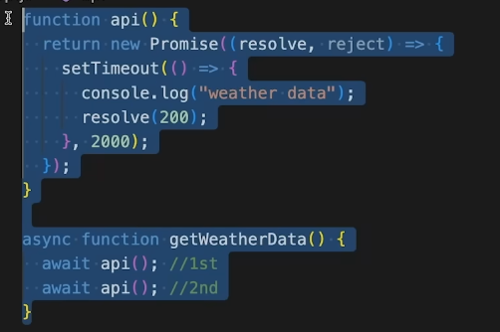

# IIFE:ImmediatelyInvokedFunctionExpression

IIFEisafunctionthatiscalledimmediatelyassoonasitisdefined.

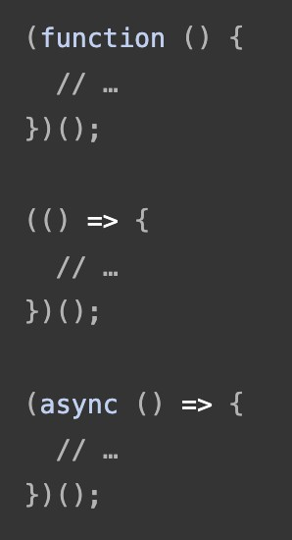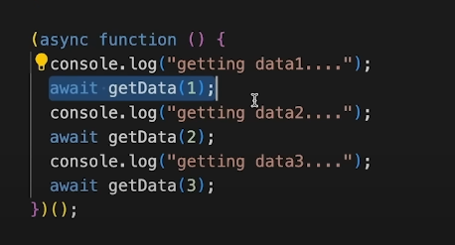 BUT IT IS NOT REUSABLE AS THERE IS NO FUCTION NAME TO CALL

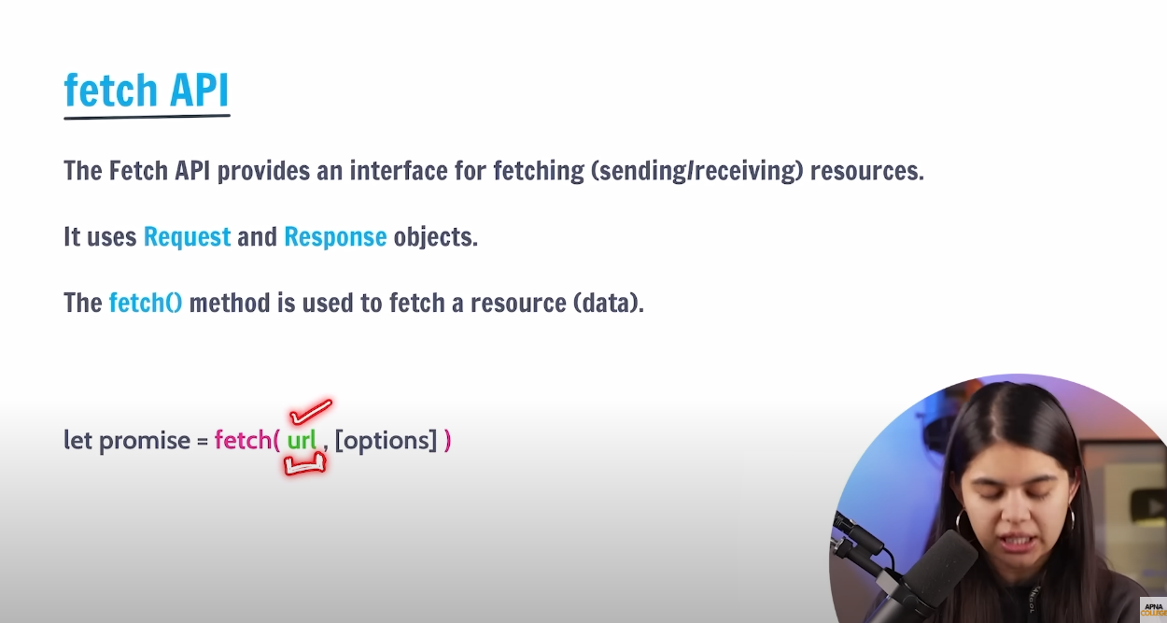

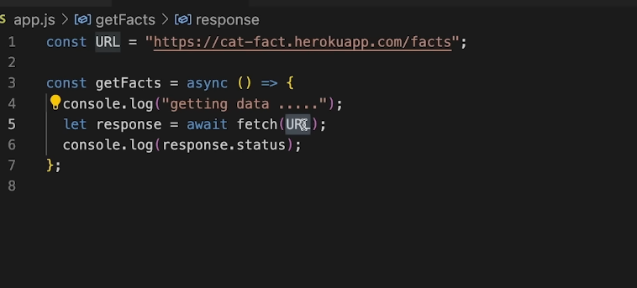

IT GIVES THE DATA IN THE FORMATE OF EITHER JSON OR XML

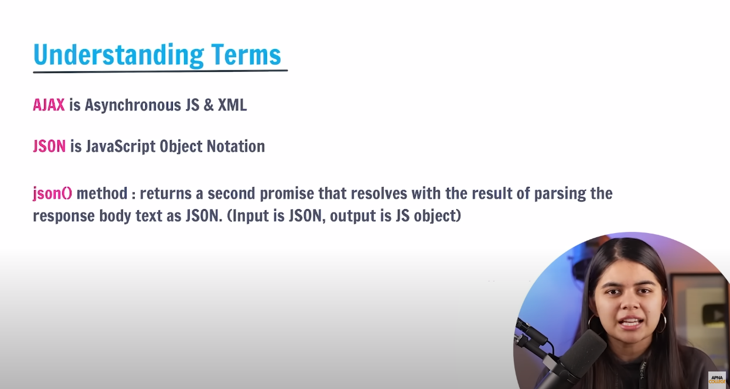

json() method converts the json formate to js object formate , it is also async function that means we must just that in the async function and use await keyword in front of it

